**13**

**Geometric Cognition**

Walter Whiteley

*York University*[1]

**Introduction**

My chapter title asserts that ‘*mathematical cognition*’ must include ‘*geometric cognition’* either as a stand-alone process or in a cognitive blend with other forms of mathematical cognition. I aim to shift our gaze to geometric cognition—or the more general equivalent “*spatial/visual reasoning in mathematics*”. Of course, the spatial representations and visual representations can be experienced across all parts of mathematics and statistics. Related cognition is found across all of the sciences and engineering and for centuries, mathematics and sciences were part of the same community, with shared cognitive processes (SIGGRAPH 2002). However, geometry offers the clearest, and often unavoidable expression of this aspect of mathematical cognition.

I am a geometer. I apply geometry in my funded applied mathematics research across a range of problems in multiple disciplines in science and engineering. I also have been teaching geometry to 3rd year mathematics majors, many of whom are preparing to teach high school. Beginning with my Ph.D. Thesis on the logical foundations of discrete geometry (*invariant theory* in the language of the 19th century), and then my growing collaborations in discrete applied geometry, my life has been immersed in geometry for about 50 years. That immersion means I have been working with spatial reasoning as: my sources of insight; my reasoning; my sharing of mathematics; my teaching; and my communication of results across multiple disciplines. Reflection within this immersion has also encouraged my research, collaborations and writing on spatial reasoning within mathematics education.

As I tell my undergraduate geometry class: “I see geometry everywhere, and want you to share that experience. Learn to recognize where a geometry lens can provide surprising insights.” By the end of the year-long course, most students report that they do not quite see geometry everywhere—but far more places that they ever had before. They also say that this class is “not like any other math class they have taken—in a good way”. The class is filled with mathematics explored through manipulatives, drawing and spatial reasoning, in multiple representations. For examples of these activities, see the text I used in this course for several decades (Henderson 2004). As the student end of year reflections confirm, such hands-on spatial / kinesthetic exploratory approach is rare as a focus within university mathematics courses—and can be missed as a conscious focus of mathematical processes. The unusual approach is appreciated by the students as challenging and sometime altering their sense of what mathematics is—or at least can be.

This chapter draws on decades of presentations and workshops with students, teachers, mathematics educators, and also conversations with a range of collaborators (Whiteley 2019, 2014, 2010, 2005, 2002, 1999). The feedback from these discussions and collaborations has been invaluable to my evolving reflections on all these issues.

**Geometric Cognition and Spatial Reasoning:**

There are so many exciting and significant experiences which connect spatial reasoning or geometric cognition to mathematical cognition. As an initial focus on Geometric Cognition, including the related spatial cognition, I will have to be selective: picking a few illustrative examples. For a broader survey of the *Big Ideas and Procedures in Geometry* where I find geometric reasoning, see (Whiteley 2019)

What are some key features of geometric cognition and spatial reasoning as I have lived them in research, teaching and learning?

1. transformations to support evolving questions, conjectures, and geometric reasoning;
2. symmetry, and invariance, as core concepts in many areas (including across physics and geometry);
3. shifting dimensions: using 3d to understand 2D;
4. multiple representations with cognitive blending: switching among representations—learning to see and recognize switching.

Let me offer a few examples of how and where these features appear in geometric cognition.

(a) The modern definition of geometry (Klein’ Erlanger Program 1872 (KleinElanger)) is that we have a space of objects and a group of transformation of that space. The study of that geometry is the study of properties which are invariant (unchanged) under these transformations. This is illustrated in Figure 1, with one classical strand of geometric, ordered upwards by inclusion of their expanding groups of transformations.

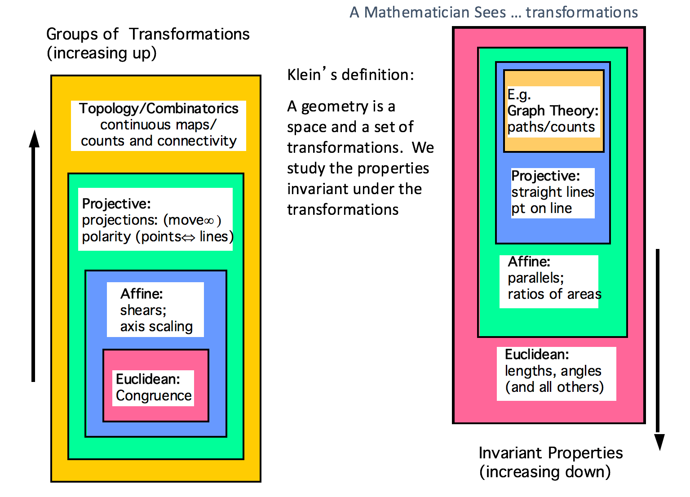

**Figure 1.** Transformations

In my own problem solving with discrete applied geometry, I begin the study of a problem with the key question (unusual among applied mathematicians): ‘which geometry should I use?’ I explore which transformations leave the solutions to the problem invariant. I have learned the importance of this question by observing: (i) cases where the problem was cast at too high a level (too many transformations) so that no coherent answer is possible, and (ii) other cases where the problem is cast at too low a level in the hierarchy—and there are too many properties and etails which are not relevant and the important patterns within the ‘forest’ are lost among the ‘trees’. For example, the static rigidity of spatial frameworks is not topological (too many transformations which lose key properties), but requires some further level of geometry. On the other hand, Euclidean geometry of distances is too low (too many irrelevant details) for statics. Static rigidity belongs to projective geometry, though most modern North American trained structural or mechanical engineers do not know those transformations (Schulze and Whiteley 2018). With more available projective transformations, many ‘different examples’ are now recognized as ‘the same’ under the transformations and one can focus on some key geometric properties and corresponding projective methods:

This grounding in transformations, embedded in a hierarchy of groups and subgroups, offers practitioners (researchers and students) thinking tools. Given an example, we play around: transforming it and seeing what else is “the same.” We find some surprises and make new conjectures. We focus on what is invariant and find representations that ‘forget’ the details that are changing and which bury the appropriate information.

A series of geometry problem solving books (written for Russian High School Students) explores this hierarchy with effective problems, figures and solutions (Yaglom I-IV). Part I works with the geometry of rigid motions of the plane (isometries); Part II uses the geometry of shape-preserving transformations of the plane (similarities); Part III focuses the geometry of transformations of the plane that map lines to lines (affine and projective transformations) and introduces the Klein model of non-Euclidean geometry, and Part IV focuses on conformal mappings that take circles to circles. The introduction to Part III gives a nice introduction to the hierarchy, which I regularly used with future teachers. Two striking images adapted from the book are recalled by students many years later (Figure 2).

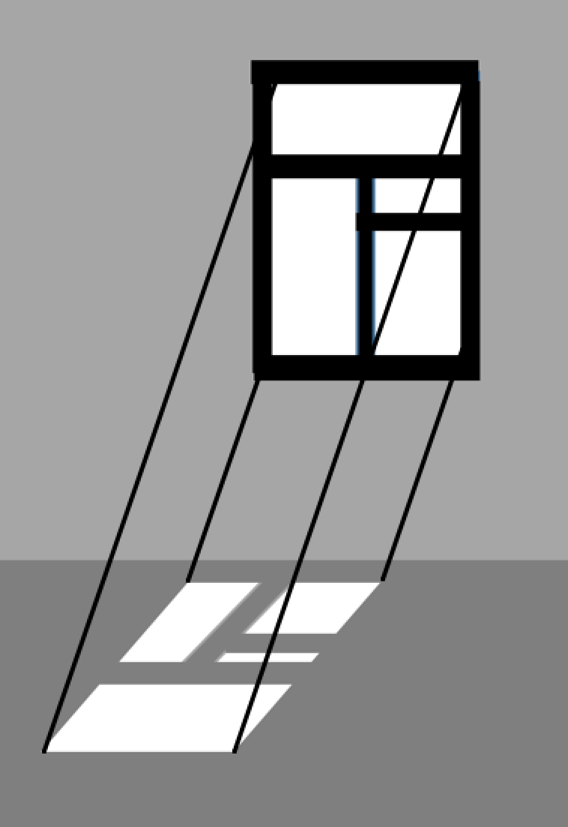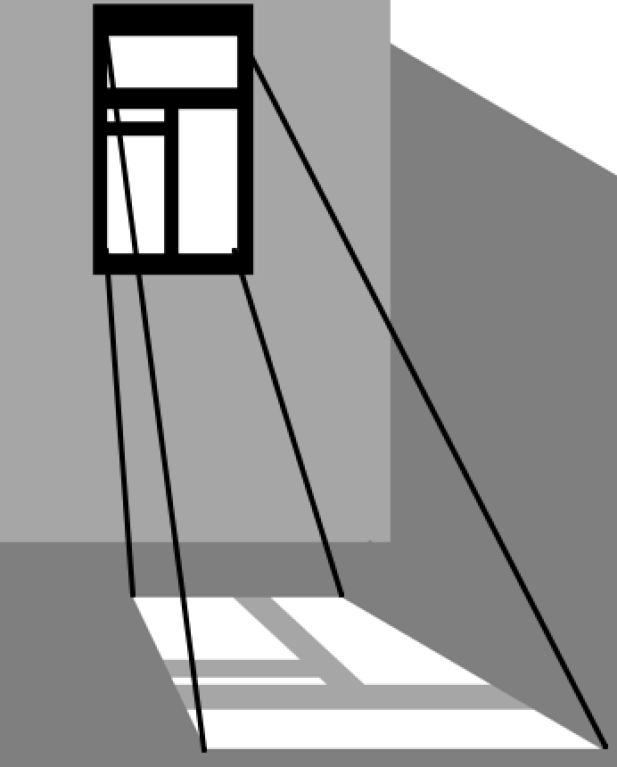

(a) Affine (sun: parallel rays) (b) Projective (ceiling light)

**Figure 2**. Affine and Projective Transformations

1. Symmetry offers a rich and engaging playground for thinking with transformations. Look at the subgroup of transformations which leave a specific object or example unchanged (invariant)—for example the symmetries of a platonic solid, or of a quadrilateral ( Whiteley and Paksu2015). When we find two symmetries, we should look for the composition of the two - filling out the table of group multiplication for the symmetries. We notice that two mirror reflections compose to form a rotation, and a rotation and a reflection compose to form another reflection. I know from students and teachers, these simple connections are lying around, underdeveloped, within the elementary curriculum as well as the university curriculum. Adding thinking geometric thinking tools boosts the interest and the connections for further learning.
2. Children live in 3-D, but the western math (and science) curriculum gives an early focus to 2D. It is a big shift for students—often needing to overcome weakness to survive in engineering and science (engage) and to thrive in mathematics. Even in my research in the rigidity of frameworks, playing among dimensions revived valued techniques, such as reworking the reciprocal diagrams of James Clerk Maxwell to connecting spherical frameworks with plane frameworks (Schulze and Whiteley 2018).
3. For the geometric / spatial thinker, transformations, including symmetries, offer a bundle of connected embodied representations: visual, spatial, kinesthetic, as well as shared patterns of group operations. These concepts form a network of embedded experiences which invite conceptually blending—and together become more richly cognitively linked as we move from one representation to another, and one brain network to another. Rapid switching among brain areas (and representations) is typical of top students, in brain scans around age 14.

These are just a few samples of the *Big Ideas in Geometry and Geometric Cognition* and themes from my decades of talks (Whiteley 2019). We will see below how some of these themes are connected both to historical developments and to how we and our students learn to reason.

**Blends with Geometric Cognition, Spatial Reasoning**

I am confirming that mathematical cognition is a blend which includes geometric cognition and spatial cognition, along with other patterns of mathematical and scientific reasoning (Fauconier and Turner 2002, Turner 2014).

It has been distracting that some earlier researchers in education, such as Howard Gardner in Project Zero (Gardner 1985), separated “mathematical intelligence” as “Logical/Symbolic Intelligence” from “Spatial/Visual Intelligence” (see Figure 3). All the recent research confirms that for children, and for many practicing mathematicians, mathematical cognition includes spatial cognition, as well as “Kinesthetic intelligence)”. These multiple intelligences of Gardner are commonly discussed in Faculties of Education (Gardner 1985, 2006) to open up diverse options for teaching and learning. This is a valuable emphasis for teachers, but this makes it more important that they have an inclusive vision and set of experience of Mathematical Intelligences (see Section 6). In my experiences teaching, learning and practicing mathematics, we blend from all of the identified intelligences in the dark box below (a graphic I use in my class with future teachers). Gardner’s recent addition of “Pattern Seeking” as an 8th intelligence is easily recognized as at the very core of the activities of mathematicians. Pattern seeking is something we ask all students to practice and develop in mathematics classrooms and beyond.

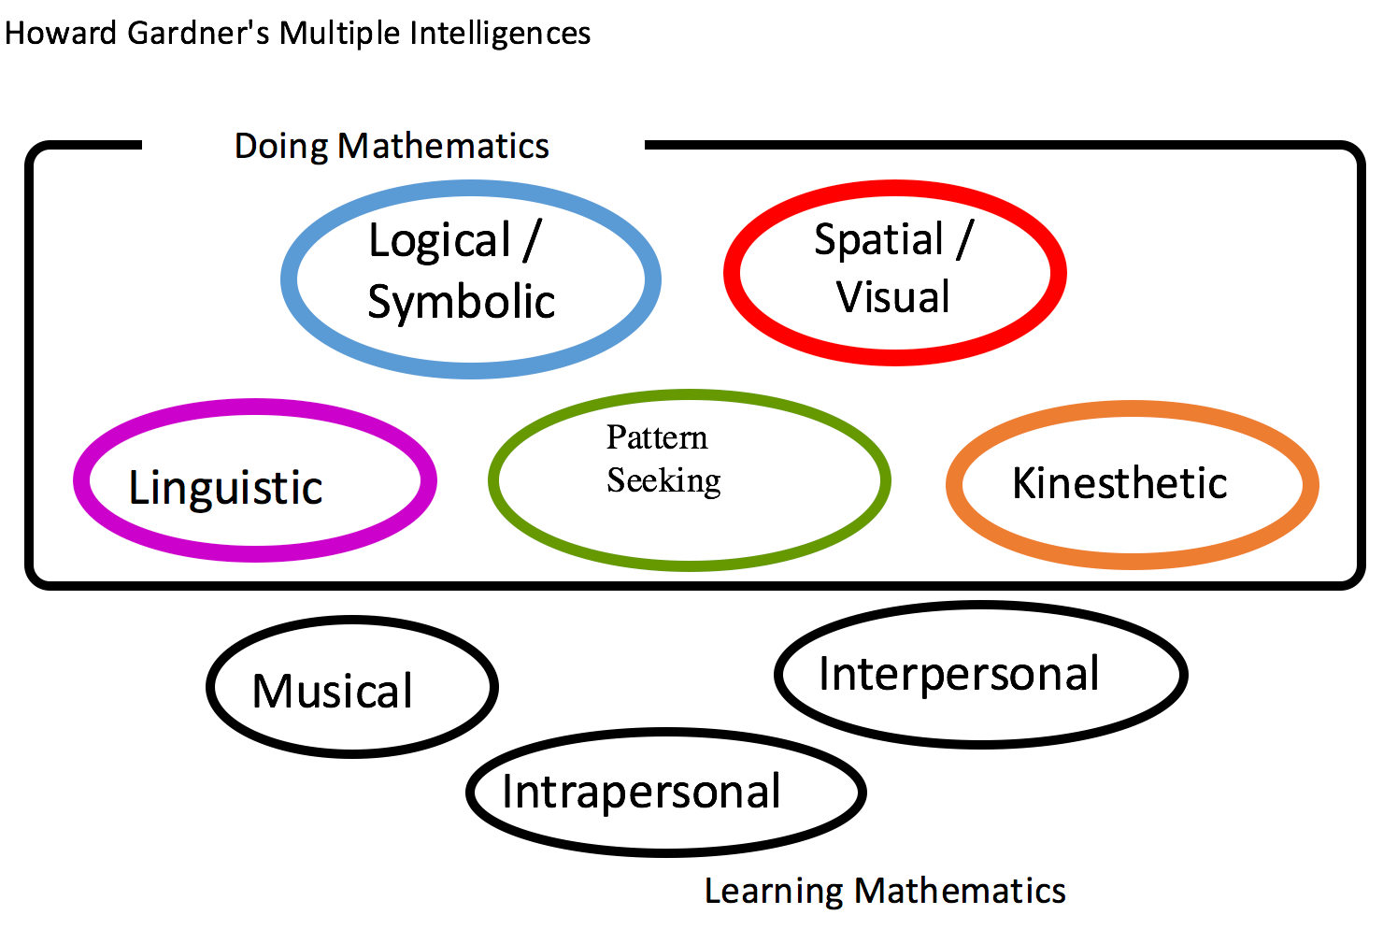

**Figure 3.** Multiple Intelligences

Often the use of physical manipulatives, supporting kinesthetic reasoning, is used in close association (a blend) with visual spatial reasoning. For example, consider the back and forth process combining dynamic geometry (a tool developed for teaching, but now used in geometry research), with paper folding, which is deeply geometric and kinesthetic (Whiteley and Paksu 2015).

One of the images I use to help future teachers notice the back-and-forth switching involved in geometric problem solving (and noticed in brain scans) is the zig-zag in Figure 4. This figure images the mental shifts from whole to part and parts back into the whole which is required in multi-step problem solving. This type of shift of focus within geometric reasoning is often hidden from students, as the teacher’s blackboard notes and gestures focus primarily on the details of ‘right side’ (b). This leaves unexplained jumps for students to puzzle out, as indicated in Figure 4 (b). We may not share the larger processes illustrated in (a)—or even be consciously aware of them to raise them up for the students to reflect on.

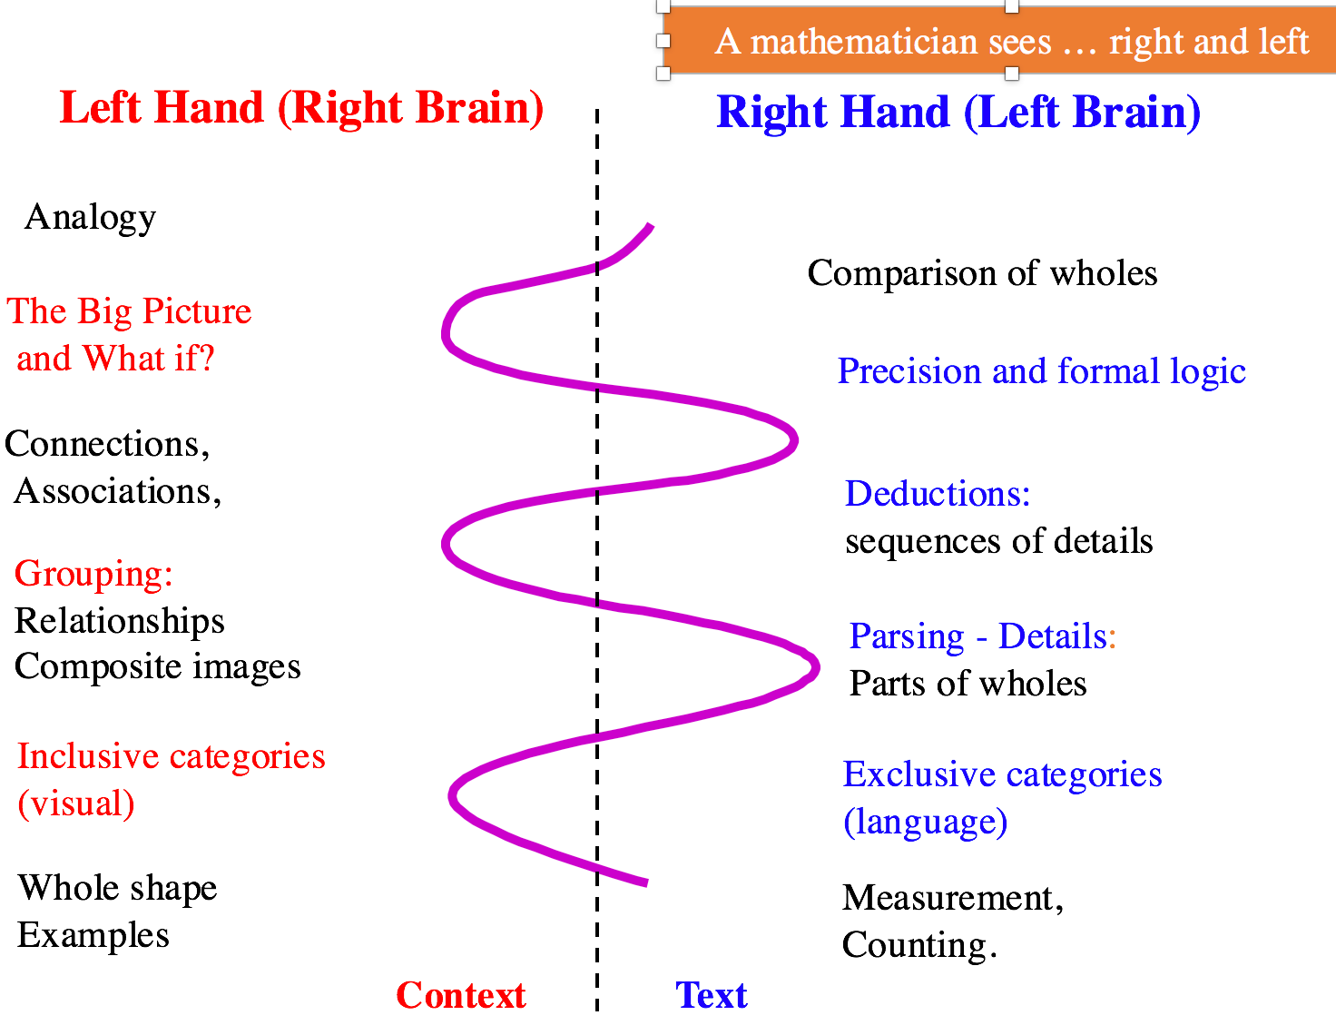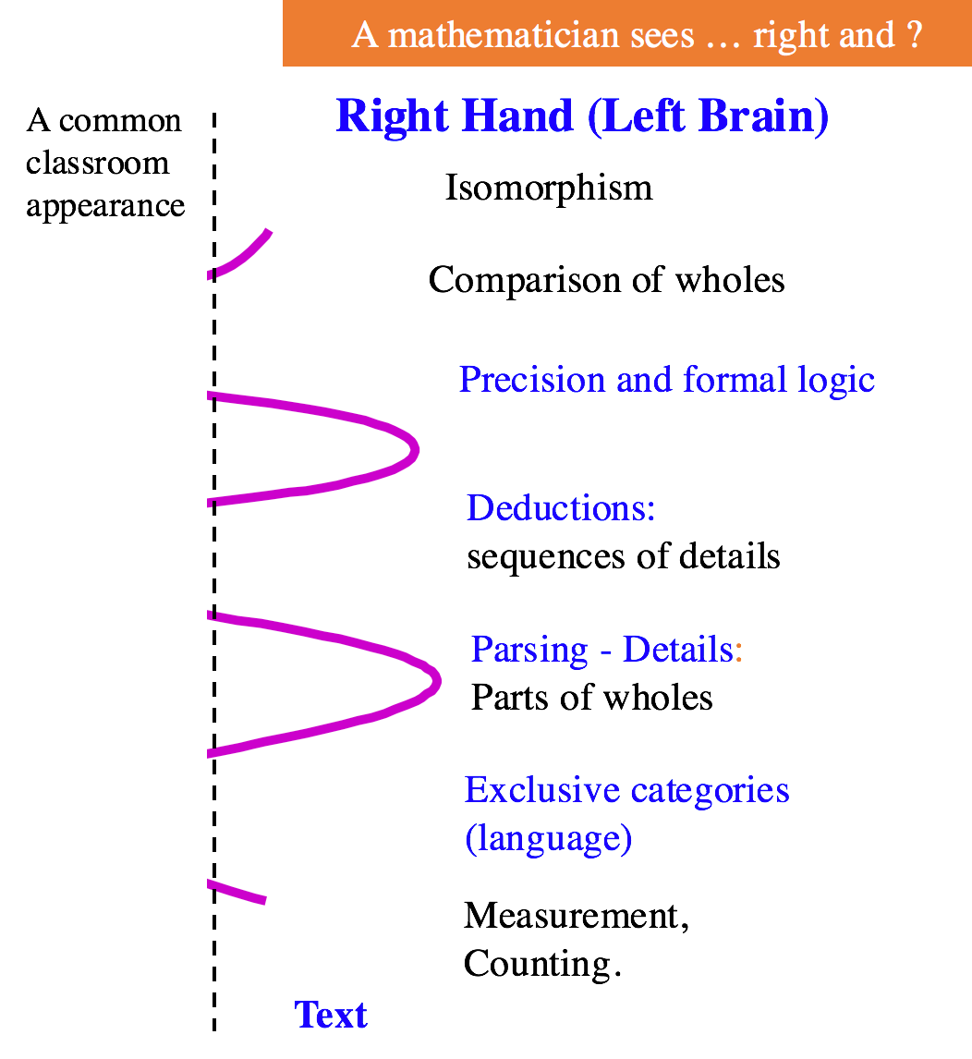

1. (b)

**Figure 4.** Mental Shifts

One recent exploration of how blending is core to mathematical modeling appears in (Whiteley2012). This analysis reflects on the classroom spatial reasoning / geometric optimization popcorn box activity described for elementary teachers in (Mamalo and Whiteley 2012). This student activity was further analyzed as “a network of and for geometric reasoning” which is explicitly connected to students developing cognitive blends in (Mamalo et al 2015).

As proposed in this analysis (Mamalo and Whiteley 2012, Mamolo et al 2015), the blend is developed through a sequence of back and forth simulations of ‘generic examples’—examples for which the reasoning does not rely on specific details but is generalizable over a wide range of variation (Mason 84). This ‘seeing the general within a particular example’ is characteristic of a lot of diagrammatic reasoning (reasoning with diagrams) and of reasoning with manipulatives. Students could identify that key choices, such as changing the scale of the model had no impact of the ‘shape optimum box’ (using proportional reasoning)—in the context of multiple physical models). When the activity was done with in-service teachers, they could also explore the analogies with a corresponding 2-D problem and some could even explore 4-D versions of the problem. Such ‘generic reasoning’ was well-developed in centuries of careful geometric practice during the centuries after Euclid. It is however a cultural practice that must be learned, and if this geometric reasoning culture is missing in the classroom or in the visible shared practices, this support for geometric cognition risks being lost to the next generation, along with other ways of doing mathematics (Whiteley 2010).

Thus overlap within neural representations reinforces the claim that these metaphors are fruitful for blending and that spatial reasoning is widely used beyond just for ‘space’.

**Recognizing the importance and centrality of spatial reasoning.**

For centuries, geometry was central to mathematics and integrated diagrams in shared mathematical practices (some of which have been lost). For example, one historical reading of the 13 books of Euclid’s Elements is that the entire program is centered on symmetry, and the books all build, with strong use of diagrams, to the 3D theorem characterizing the 5 Platonic solids. This suggests the elements are based on geometric reasoning as spatial reasoning. The common focus on teaching this ‘elementary’ geometry through ‘formal—symbolic proofs’ ignores these aspects of spatial geometry—to the loss of students and teachers (Tall et al 2012, Whiteley 2010, 1999). We return to this theme in Sections 5 and 6 below.

A striking and well-documented example of effective geometric cognition is the work of Michael Faraday on electro-magnetism (West 2009, Goodings 2006). Faraday’s 1821 notebooks for the day he built the first electric motor displays his problem solving in an essentially visual / diagrammatic form. The notebooks record a back and forth between (i) the laboratory experiments (recorded with a diagram and then a sequence of observations recording changes as more diagrams), and (ii) planning using some doodling followed by a new diagram for the next experiment. In his work, Faraday invented some new diagrammatic forms to capture his quantitative reasoning with figures, as illustrated in the now standard diagram of ‘lines of force’ (Figure 5).

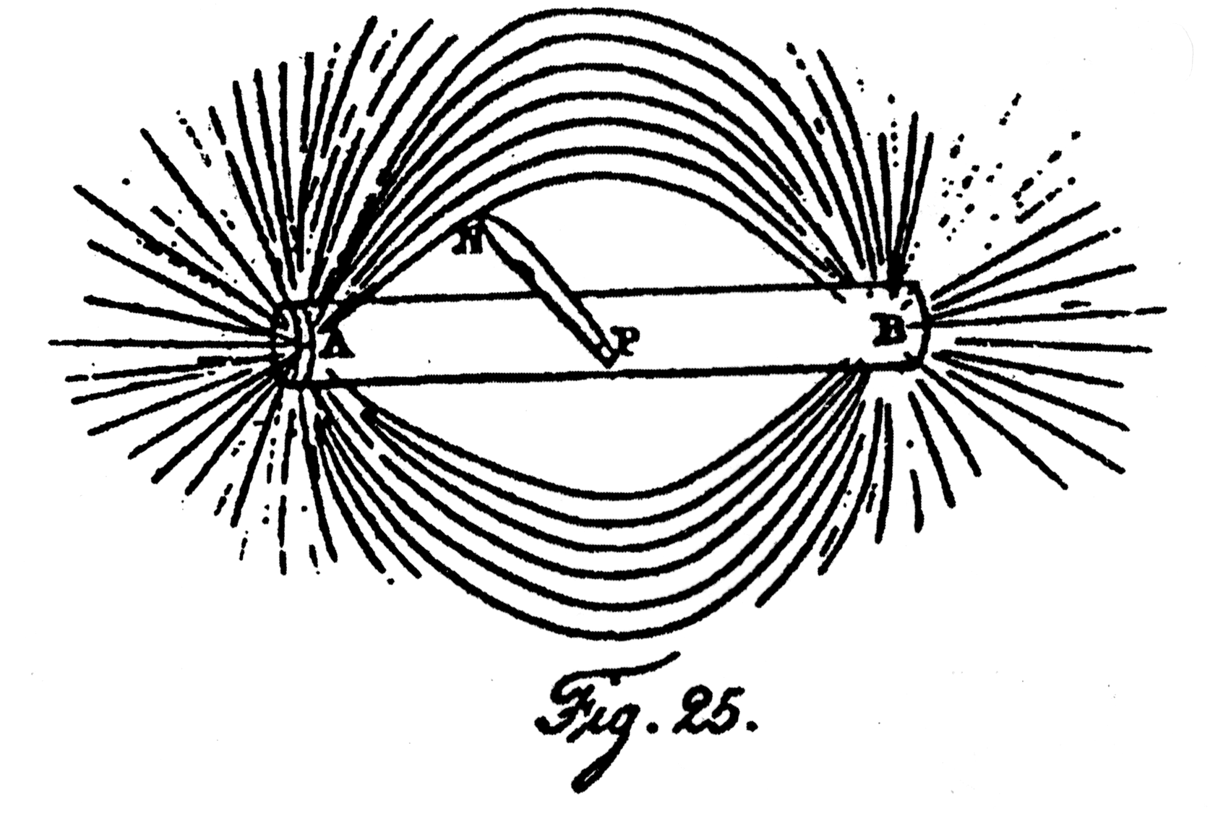

**Figure 5.** Lines of Force

All the historical evidence is that Faraday did not, and could not, work with equations (West 2009). Faraday worked with what I am calling geometric cognition. Nevertheless, he reasoned out results such as Faraday’s laws of electro- magnetism which we now write with equations. This way of reasoning was recognized as “mathematical cognition” by one of the great figures of this field - James Clerk Maxwell: “As I proceeded with the study of Faraday, I perceived that his method of conceiving phenomena was also a mathematical one, though not exhibited in the conventional form of symbols” (James Clerk Maxwell, as quoted in West 2009).

Maxwell wrote that this use of lines of forces show Faraday "to have been in reality a mathematician of a very high order—one from whom the mathematicians of the future may derive valuable and fertile methods”. I agree that there are fertile methods here, but unfortunately, if current students rely on such visual methods, todays schooling often identifies them as failing mathematics—and not suitable to become engineers.

In the mid 20th century, the eminent mathematician Jacques Hadamard interviewed a number of leading mathematicians of his generation asking them to describe how they “invented” their mathematics (Hadamard 1945). A key observation was that they wrestled with a problem (exploring the pieces that might become a blend) and then set the problem aside. Their first conscious awareness of the new insight of how to solve the problem was in visual (spatial) form. The recognition of what I call ‘a cognitive fitting together of pieces towards the solution with the problem’ was in the visual form. This provided a platform to support further exploration and re-presentation in a problem solving blend of connections.

George Polya is widely recognized as a combinatorist, as a student of mathematical problem solving and as an mathematics expositor and teacher (Polya 1954a, 1954b). In his review of ‘Plausible Reasoning’, the mathematician Paul Halmos summarized the central thesis in this way:". a good guess is as important as a good proof." To me, this is capturing the insights of visual reasoning—which are prior to the formal, logical and symbolic reworking of the problem. In his expository paper ‘On Picture Writing’ (Polya 1956). Polya makes visible a good sample of his reasoning when shifting from diagrammatic representations of a counting problem to a symbolic algebraic generating function. The paper contains two, full page, samples with a sequence of ‘equivalent representations’ of the problem, one line each. Each step records a shift of both the representation and the associated operations, in reversible steps. It is a wonderful expression which makes visible to all of us the otherwise invisible reasoning of this master problem solver—something we do not encounter often enough.

While not the reflections of a mathematician, Temple Grandin expresses well what working primarily with spatial reasoning is like in her autobiographical book ‘*Thinking in Pictures*’ (Grandin 2006). This book echoes stories of other historical figures who relied on vivid and effective spatial reasoning, such as Nicholas Tesla, and Faraday (West 2009). This way of working becomes at least one option within a broader blended Mathematical Cognition which includes geometric cognition. The very ways we share our work in publications over emphasizes words, symbols and formulas (which are easier to put down on the page) gives priority to later formal reasoning over also presenting the geometric reasoning which were the basis for our insights. We have limited tools for sharing spatial reasoning, and we often lack enough shared conventions for sharing spatial/visual reasoning.

Burton (2004) describes a more recent study in which she interviewed a wide range of researchers in mathematics and statistics about how they did their work. One of the themes was the wide range of approached, including analytic, conceptual, and visual thinking, Visual thinking was documented as central by some participants, and an important option among several by others. Insights from self-reflection are necessary sources, as just reading the published articles gives a skewed impression. As mentioned above, mathematicians often select the analytic (algebraic, computational) presentation, in preference to the more difficult to present visual/geometric presentation. As I referee research articles, I often recommend more figures and more examples. To paraphrase the responses of some colleagues to why they do not include more figures: ‘when I read an article, I draw my own pictures—doesn’t everyone’? Again, this self-selection is rendering the spatial/visual basis for the work invisible.

Over the centuries, there has been changing emphasis on spatial reasoning. In (Whiteley1999), I draw on my communities experiences to propose a narrative for how geometry faded in North America, particularly in the second half of the 20th century. This culture-shift contributed to the breaking of continuity of geometric practices based the central role of spatial/reasoning which was obvious in earlier periods, and has almost been lost by the 21st century. What I also claim, drawing on evidence from the curriculum in both Undergraduate and Graduate Programs across disciplines, and evidence in current scientific research, is that geometry still remains essential to solving problems in many areas of applied mathematics. However, this geometry may now only surface in other disciplines, when the required geometric cognition is no supported within pure and applied mathematics programs.

In my own research and teaching experience, spatial/visual reasoning is more salient in applied mathematics than in pure mathematics. It was also more salient in mathematics prior to the 20th century (Tall et al 2012, Whiteley1999). Visual presentation of examples and results still remains the standard for sharing mathematical and statistical reasoning across multiple disciplines. For sample resources which support communication: see Howard Wainer’s :*Visual Revelations*, and *Graphic Discovery, Picturing an Uncertain World* (Wainer 2000, 2007), as well as the discussion and appendices in the White Paper: *Visual Learning for Science and Engineering* (SIGGRAPH 2002).

In talks and workshops, I often present examples where the spatial reasoning becomes visible “with eye and hand”. In “*The Case for Mental Imagery*” (Kosslyn 2006), addresses the controversy within cognitive science and philosophy of whether images (and therefore spatial reasoning) are actually found in our internal cognition. Kosslyn presents strong evidence that what we call images are also present in the brain—and we think with, and operate on these mental images as we do on external images. Spatial reasoning can be done with our eyes closed and our hands not moving—including operations like mental rotation. For example, mental rotations develop early for children (e.g. when learning infant sign language) and this ability remains an important spatial reasoning skill which continues to be tested through to mechanical reasoning tests. Mental rotation regularly occurs entrance tests for medical and dental school (Davis et al 2015). Weak abilities in spatial reasoning becomes a negative filter for many careers—so developing such abilities or reasoning is an important challenge.

**Development of Geometric Reasoning**

There is now a wide recognition of key role of geometric cognition in the larger development of mathematical cognition, at least for young children. There is a large literature on using spatial reasoning in the learning of mathematics (see the multiple chapters in (Davis et al 2015), where our spatial reasoning group reviewed a range of the literature and described examples. A recent book with the title: ‘*Visualizing Mathematics; The Role of Spatial Reasoning in Mathematical Thought*’ also describes the key role of geometric cognition (Mix and Battista 2018). I will not repeat the references and links from these books.

Children are born into space, learning to see and to move, even from before birth. By the time they enter school, they have learned varying amounts of 3-D spatial reasoning—depending on the activities they did, and what the adults around them direct their attention to, in part through use of spatial language (Davis et al 2015). One of the chapters this book specifically explores the connections between 2-D and 3-D reasoning. (Burke et al 2017) makes the connection of 3-D work to embodied cognition—a connection also found in (Davis et al 2015) and implied by my earlier phrase of ‘working with eye and hand’. Unfortunately, this prior knowledge of 3-D is often neglected in early schooling. I sometimes say that we take the students who have lived in 3-space, and then ‘flatten their reasoning into the plane’ as they enter grade 1!

In ‘*Visual Intelligence:* *How We Create What We See*’ (Hoffman 2000), Donald Hoffmanspeaks to how we can change what we see, based on experience. As the neurologist Oliver Sacks has said, “when we open our eyes each morning, it is upon a world we have spent a life-time learning to see”. This means that what I see is not the same as what you see—and we can change what we see. This is true for how we see geometry, and more generally what we notice in mathematics and statistics (Whiteley2005, Whiteley2012, Whiteley2014). In an analogy to Betty Edwards’ insights into learning to draw by first learning to see (Edwards 2009), I claim that for many students “learning to see like a mathematician” opens a new door to success in mathematics and statistics (Whiteley2005, Whiteley2012, Whiteley2014). Supporting this type of brain changing learning is also explored in the appendices of the White Paper (SIGGRAPH 2002).

Froebel, the inventor kindergarten, began his sequence of activities (Gifts) with a series of 3-D spatial activities using rich precursors of our now simplified building blocks (and now somewhat richer Lego) (Brosterman 1997). Drawing on his prior work in crystallography, and in hands on learning, Froebel engaged children in 3-D activities and the very name ‘kindergarten’ reminds us that each child had a small garden plot (Brosterman 1997)! The activities included symmetry and transformations, still common in much of the hands on work with manipulatives. It does not seem to be a coincidence that Frank Lloyd Wright’s mother was a Froebel Kindergarten teacher—and he continued to play with spatial visual cognition in his design work (Brosterman 1997). Later gifts in Froebel’s sequence included 2-D activities, still with manipulatives, and often with symmetry.

As Davis et al (2015, Burke et al (2017), and Froebel notice, 3D comes before 2-D for children. This is a critical concern identified by a number of mathematics educators. The eminent Canadian geometer Donald Coxeter contributed to the draft of a rich *Geometry K-13 OISE Report* (Geometry 1967) which started with 3D, and with visual reasoning, and built from there. These far sighted curriculum drafters included activities such as work with vectors in grade 4-5. This is the age at which children are actually working with maps and compasses to navigate in their world outside of school (a basic geometric task). Sadly, this curriculum was never implemented. A few years ago when I proposed vectors as sample activity to some curriculum writers, there was full agreement that children could do this mathematical activity at age 10. The barriers to enriching the curriculum were (i) that the current teachers probably could not handle it, and (ii) such a spatial theme did contribute immediately to the otherwise “calculation and algebra based curriculum” which was driven to get students ‘ready for calculus’ by the end of high school. The general result of these obstacles in North America is an impoverished exposure in school to only a few aspects of mathematical cognition and effective problem solving, with little spatial/visual reasoning!

The mathematics educator Jo Boaler highlights the damaging myth in mathematics education that visual/spatial reasoning (with hands to count, and diagrams to reason with) is only for young students, weak students or lay people (non-mathematicians) (Boaler et al 2016). She notes that (West 2009) describes this myth as centuries old—and that there is compelling brain science to contradict this myth. The examples and studies in this section also contradict this myth. In our terms, expert brains contain the key blends that retain these visual/spatial connections, even when we appear to be working with another, more abstract level of the blend. We continue present school mathematics with only one part of the rich, thick cognitive network of concepts and representations, weakening any support for spatial cognition, and for students who depend on this part of the blend.

To return to Klein’s Hierarchy from Section 2, Piaget’s trajectories for children’s stages of learning geometry fits well with moving down Klein’s Hierarchy. Simple topology is explored early—with questions about ‘what is connected to what’ as the child explores: “what can I reach”? “Can I go out one door of a room and come back through another door?” Then learning extends to straight lines: anticipating where a toy train that entered a tunnel will emerge? what is the shortest path to follow?—all part of (projective geometry). The last concepts mastered by children in schools are concepts like volume and area (Euclidean), around age 8-10 (Grade 4).

While children learn spatial reasoning early, they can, and often do, lose these abilities during puberty and high school. In some longitudinal studies following improved spatial reasoning from piano training developed at age 4, it was found that the improved spatial reasoning was scrambled to just chance during puberty. (See (Rauscher et al 1997) and their following studies.) Other studies confirm a decline of 3-D spatial reasoning during high school years, when the curriculum does not practice spatial reasoning or make evident to students that spatial reasoning is a critical prerequisite skill for many university programs and careers. These students graduate to face shock of the necessity of spatial reasoning to succeed in their chosen programs across engineering, sciences and mathematics.

We offer a quote from work on the urgency of developing Spatial Reasoning for Engineering (Engage): “Most engineering faculty have highly developed 3-D spatial skills and may not understand that others can struggle with a topic they find so easy. Furthermore, they may not believe that spatial skills can be improved through practice, falsely believing that this particular skill is one that a person is either “born with” or not. They don’t understand that they probably developed these skills over many years. We don’t encourage students not ready for calculus to enroll in calculus in their first semester. Shouldn’t spatial skills training be available for those who need the help?: Sheryl Sorby, quoted at ENGAGE: Spatial Reasoning for Engineering.

There is convincing evidence that spatial reasoning is malleable for people over a range of ages from zero through middle age (Davis et al 2015, Uttal et al 2013). My experience, in multiple classes and workshops over the last 30 years is that students, including future teachers, are concerned about their weakness in spatial reasoning—and they are very encouraged to learn that they can still continue to improve spatial skills. The same observation is true for classes and workshops with in-service teachers, as they recognize they can then both be better in their own mathematics, and can better support students who may be primarily approaching mathematics (and other subjects) through spatial / visual reasoning.

For undergraduate mathematics majors, this encounter with their gap spatial reasoning often happens, even to high achieving mathematics students, in their third course in calculus: multivariable calculus. The ENGAGE website and Sorby speak to both the importance of spatial reasoning and describe short programs (10 hours) which (re)-build spatial reasoning for retention and success in key programs such as engineering. The gap in support for this critical skill continues into many university programs—as spatial reasoning becomes a filter for who will remain in programs, rather than another important skill to be developed.

Papers such as Mann (2005), Silverman (1995) describe gifted students who rely on spatial reasoning and are underserved and under-supported in programs and classrooms which omit spatial reasoning. These papers also describe effective classroom techniques to support such students. Faraday would have been such an under-served student—and would not have survived our schooling to enter an engineering program in our century. The losses for mathematics and sciences and our larger society for undervaluing geometric cognition are large.

**Going Forward**

I highlight two promising themes as directions for future work on Geometric Cognition.

1. Aging and losing our mathematical minds.

A lot of research has focused on how we learn different mathematical abilities when we are young or even middle aged. At the other end of life, during aging, we may experience critical stages of cognitive decline. In particular, various mathematical abilities are lost, most visibly in neurodegenerative diseases such as Alzheimer’s, Parkinson’s and more generally dementia (Possin 2010). This survey includes an exploration of different facets of visual/spatial cognition—in terms of brain areas and networks that can be disrupted in the changing brain. The different forms of loss in spatial reasoning are diagnostic of different neuro degenerative diseases and different forms of dementia. These losses in spatial cognition are often documented with tests such as the *Montreal Cognitive Assessment* (MoCA) which has a surprising focus on spatial reasoning. Overall, the study of loss of spatial reasoning promises additional insights into how spatial reasoning is processed in our brains, at all ages.

The loss of spatial reasoning, such as navigation and spatial (distance) perception can have a big impact on people, including the loss of a driver’s license and associated independence. I conjecture that the loss of spatial reasoning is also related to other losses in aging—such as a sense of which day it is (the loss of a mental calendar as spatially organized), and what the daily schedule is (the time-line as a spatial orientation). Given how much spatial ability contributes to learning arithmetic, one has to also wonder whether the loss of spatial reasoning contributes to decline in the ability to calculate or do proportional reasoning (e.g. figure out a tip in the restaurant).

With the research emphasis on how mathematical cognition is developed, and our aging population, it would be timely to study how mathematical cognition declines. “Losing our mathematical minds” is an important life stage. Finding strategies for maintaining and supporting spatial cognition should be a parallel to finding ways to maintain language abilities. The losses are commonly identified in the current tests, and some of the computer based programs being tested are spatially focused. However I have not seen a good survey of support systems for geometric cognition, or more generally for all forms of mathematical cognition, as we age.

More generally, changes in aging brain pose the question of understanding how established cognitive blends are broken, and perhaps how to thicken the connections within a blended network, so that the blend is more resilient as we age. A “good-enough blend” may not last as we age and change. We may also blur across some blends and incorporate other connections which are not helpful, as the brain ages. We “learn how to see”—and we can also lose to ability to perceive connections and metaphors well. As I write this, I recognize I am showing my age and describing my current community!

1. Geometrizing / Spatializing the Curriculum.

Davis et al (2015) and Boaler et al present the overall challenge of spatializing the curriculum, and enriching it with visual activities—a challenge that applies to all stages of education. This can only happen when many people decide geometric cognition, or spatial/visual skills, are important. Only a strong recognition of both how this spatializing of the curriculum will strengthen the mathematical cognition of all students, and the recognition that failure to include this spatial content means the exclusion of many students. The diversity of cognitive styles and prior knowledge among students excludes many who could be major contributor in a more supportive classroom context.

An essential part of such an enrichment is a educating a generation of teachers who themselves have experienced the value of spatial/visual reasoning, and therefore are eager to incorporate these activities in their classrooms. In my own classrooms and within my wider community of university geometry teachers, Henderson’s ‘Experiencing Geometry’ has provided such support for decades of future teachers (Henderson 2004). When the future, or current, teachers reflect on how they have been with eye and hand, they consistently want their own students to experience that support and engaged in spatializing their classrooms.

I am hopeful of a future with a rising of geometry and support for geometric cognition during the 21st century

**References**

Boaler, J. Chen L., Williams, C., Cordero, M. (2016). Seeing as understanding: The importance of visual mathematics for our brain and learning. *Journal of Applied Computational Mathematics* 5: 325.

[Brosterman](https://www.amazon.ca/s/ref=dp_byline_sr_book_1?ie=UTF8&field-author=Norman+Brosterman&search-alias=books-ca), N. (1997). *Inventing kindergarten*. New York: Harry N. Abrams.

Burke, H., Gardony, A., Hutton, A., and Taylor, H. (2017). *Thinking 3d! Improving mathematics learning through embodied spatial training*; Cognitive Research: Principles and Implications (2017), 1-18.

Burton, L. (2004). *Mathematicians as enquirers: Learning about learning mathematics.* New York: Springer.

Cánovas, C. P. and Monzanares, J. V. (2014).Conceptual mappings and neural reuse. *Frontiers in Humuan Neuroscience* 29 April 2014 <https://doi.org/10.3389/fnhum.2014.00261>

Copelewicz, J. (2019). The brain maps out ideas and memories like spaces. *Quanta Magazine*. <https://www.quantamagazine.org/the-brain-maps-out-ideas-and-memories-like-spaces-20190114/>

Danesi, M. (2018). *Learning and teaching mathematics in the global village: Mathematics in the digital era*. New York: Springer.

Davis, B. et al (2015). *Spatial reasoning in the early years: Principles, assertions, and speculations*. New York: Routledge.

Edwards, B. (1999). *Drawing on the right side of the brain*. New York: Tarcher.

Engage (2019). Spatial reasoning for engineering (accessed January 2019) <https://www.engageengineering.org/spatial/whyitworks/>

Fauconnier, G. and Turner, M. (2002). *The way we think: Conceptual blending and the mind’s hidden complexities*. New York: Basic Books.

Gardner, H. (1985). Frames of mind: The theory of multiple intelligences. New York: Basic Books.

Gardner, H. (2006). *Multiple intelligences: New horizons in theory and practice*. New York: Basic Books.

Geometry (1967). *Geometry K-13 OISE Report 1967* [www.math.yorku.ca/~whiteley/geometry.pdf](http://www.math.yorku.ca/~whiteley/geometry.pdf) Posted with permission of the Ontario Institute for Studies in Education of the University of Toronto.

George, W. (2017). Bringing van Hiele and Piaget together: A case for topology in early mathematics learning. *Journal of Humanistic Mathematics* 7: 105-116.

Goodings, D. C. (2006). From phenomenology to field theory: Faraday’s visual reasoning. *Perspectives on Science* 14: 40-65.

Grandin, T. (2006). *Thinking with pictures: My life as an autistic*. London: Bloomsbury.

Hadamard, J. (1945). *The psychology of invention in the mathematical field.* New York: Dover.

Halmos, P. (1955). Review of Polya. Bulletin of the American Mathematical Society 61: 243-245.

Henderson, D. and Taiminia, D. (2004). *Experiencing geometry: Euclidean and non-Euclidean geometry with history.* Boston: Pearson.

Hoffman, D. (2000). *Visual intelligence: How we create what we see*. New York: W. W. Norton and Co.

Kosslyn, S., Thompson, W., and Ganis, G. et al (2006). *The case for mental imagery*. Oxford: Oxford University Press.

Klein, F. (1924) *Elementary mathematics from an advanced standpoint*: *Geometry*. New York: Dover.

Klein’s Erlanger Program: <https://en.wikipedia.org/wiki/Erlangen_program>.

Mamalo, A., Ruttenburg-Rozen, R., Whiteley, W. (2015). Developing a network of and for geometric reasoning. *ZDM: International Journal on Mathematics Education* 47: 483-496.

Mamalo, A. and Whiteley, W. (2012). The popcorn box activity and reasoning about optimization. *Mathematics Teacher* 105(6): 420-426.

Mann, R. (2005) Gifted students with spatial strengths and sequential weaknesses: An overlooked and under-identified population. *Roeper Review* 2005

Mason, J. and Pimm, D. (1984). Generic examples: Seeing the general in the particular. *Educational Studies in Mathematics* 15: 277-289.

Maxwell, J. Clerk (2003). *The scientific papers of James Clerk Maxwell.* New York: Dover.

Mix, K. and Battista, M. (eds.) (2018). *Visualizing mathematics; The role of spatial reasoning in mathematical thought*. New York: Springer.

Polya, G. (1954a). *Mathematics and plausible reasoning. Volume I: Induction and analogy in mathematics*. Princeton: Princeton University Press.

Polya, G. (1954b). *Mathematics and plausible reasoning. Volume II: Patterns of plausible inference.* Princeton: Princeton University Press.

Polya, G. (1956). On picture writing. *American Mathematical Monthly* 63: 687-697.

Possin, K. L. (2010). Visual spatial cognition in neurodegenerative disease. *Neurocase* 16(6): 466-487.

Rauscher, F. H. et al (1997). Music training causes long-term enhancement of preschool children’s spatial-temporal reasoning. *Neurology Research* 19(1): 2-8.

Schulze, B. and Whiteley, W. (2018). Rigidity and scene analysis. In: C. Toth, J. Goodman and J. O’Rourke (eds.), *Handbook of Discrete and Computational Geometry*.

SIGGRAPH (2002). *White paper: Visual learning for science and engineering*. 2002 <http://education.siggraph.org/conferences/other/visual-learning>

Silverman, L. K. (1995) Effective techniques for teaching highly gifted visual-spatial learners. https://eric.ed.gov/?id=ED418535 (with full text).

Sorby, S. (2019). Higher education services: Visualizing success https://www.higheredservices.org/ (accessed Jan 2019). See also the TedX talk: <https://www.youtube.com/watch?v=cJZIhl28HFI>

Tall, D. et al (2012). Cognitive development and proof. *Proof and Proving in Mathematics Education,* Michael de Villiers and Gila Hanna (eds.), April 2012.

Turner, M. (2014). *The origin of ideas: Blending, creativity, and the human spark*. New York: Oxford University Press.

Utall, D. H. et al (2013) The malleability of spatial skills: A meta-analysis of training studies. *Psychological Bulletin* 139: 352-402.

West, T. (2009). *In the mind’s eye: Creative visual thinkers, gifted people with dyslexia, and the rise of visual technologies*. New York: Random House.

Wainer, H. (2007). *Graphic discovery: A trout in the milk and other visual adventures*. Princeton: Princeton University Press.

Wainer, H. (2000) *Visual revelations: Graphical tales of fate and deception from Napoleon Bonaparte to Ross Perot*. New York: Psychology Press.

Whiteley, W. (1999). The decline and rise of geometry in 20th century North America. *Proceedings of the 1999 CMESG Conference*. [www.math.yorku.ca/~whiteley/cmesg.pdf](http://www.math.yorku.ca/~whiteley/cmesg.pdf)

Whiteley, W. (2002). Teaching to see like a mathematician [www.math.yorku.ca/~whiteley/Teaching_to_see.pdf](http://www.math.yorku.ca/~whiteley/Teaching_to_see.pdf)

Whiteley, W. (2005). Learning to see Like a Mathematician.In: G. Malcom (ed.), *Multidisciplinary approaches to visual representation and interpretation*, pp. 279-292. Oxford: Elsevier.

Whiteley, W. (2010). As geometry is lost—What connections are lost? What reasoning is lost? What students are lost? Does it matter? *Plenary Talks PIMS Changing the Culture* 2010. <https://www.pims.math.ca/files/AsGeometryIsLost_0.pdf>.

Whiteley, W. (2012). Mathematical modeling as conceptual blending: Exploring an example within mathematics education. In: M. Bockarova, M. Danesi, and R. Núñez (eds.), *Cognitive science and interdisciplinary approaches to mathematical cognition*. München: Lincom Europa.

Whiteley, W. (2014). Seeing like a mathematician: There is a diversity of ways to support the active learning of mathematics, Paper and Presentation at [Forum for Action: Effective Practices in Mathematics Education’](https://mathforum1314.wordpress.com/) <https://mathforum1314.wordpress.com>

Whiteley, W. (2019). *Big ideas in geometry*, <http://wiki.math.yorku.ca/index.php/Big_Ideas_Concepts_Procedures> (accessed January 2019).

Whiteley, W. and Paksu, A. D. (2015). *Reasoning with quadrilaterals using hands, eyes, and technology*, Workshop, Ontario Association of Mathematics Educators Annual Conference, May 2015 <https://www.researchgate.net/publication/322505303_Reasoning_with_Quadrilaterals_using_hands_eyes_and_technology>.

Yaglom, I. M. Yaglom: *Geometric transformations* I-IV; MAA New Mathematical Library Vol 8, 21, 24, 44; 1962, 1968, 1973, 2009.

1. Work supported in part by grants from NSERC (Canada) and SSHRC (Canada)